**CareConnect: Government Health Camp CRM**

Project Overview

Build a Salesforce CRM application to manage end-to-end scheduling, outreach, and follow-up for government health camps. The system will be used by local health camp coordinators, medical teams, and government supervisors:

* Citizens can pre-register or walk in and be assigned time slots.
* Staff and equipment are allocated based on camp size and patient needs.
* Automated reminders, status tracking, and integrated feedback collection improve participation and care quality.

Objectives

* Automate scheduling for patients, doctors, and equipment to maximize efficiency.
* Provide real-time reporting to supervisors on registrations, resource allocation, and follow-ups.
* Enhance patient experience with automated reminders and streamlined onsite check-in.
* Track outcomes and gather feedback for future improvement, ensuring accountability.
* Integrate workflows with WhatsApp/SMS for communication, making it practical for mass outreach.
* **Phase 1: Problem Understanding & Industry Analysis**

**1. Introduction**

This document outlines the Phase 1 activities for the **CareConnect: Government Health Camp CRM** project. This phase focuses on understanding the core problem, analyzing stakeholder needs, mapping business processes, and researching industry use cases specific to government health camps.

**2. Problem Statement**

Government-run health camps in rural and semi-urban areas face challenges including:

* Poor patient scheduling leading to long wait times and overcrowding.
* Inefficient utilization of medical staff and equipment resources.
* Limited follow-up on patient health outcomes post-camp.
* Lack of automated reminders, reporting, and feedback mechanisms.

These challenges reduce the impact and efficiency of government health outreach programs.

**3. Objectives**

* Automate scheduling for patients, medical staff, and equipment to maximize resource utilization.
* Provide a streamlined registration and appointment system for citizens.
* Enable real-time tracking and reporting for health camp coordinators and government supervisors.
* Improve patient engagement through automated notifications and feedback.
* Support data-driven decision-making for future health camps.

**4. Stakeholder Analysis**

|  |  |  |
| --- | --- | --- |
| Stakeholder | Role | Needs/Expectations |
| Citizens / Patients | Health camp attendees | Easy registration, appointment slots, reminders |
| Health Camp Coordinator | Camp organizers | Efficient scheduling, resource allocation |
| Medical Staff | Doctors, nurses, technicians | Clear appointment lists, staff assignments |
| Government Supervisors | Monitoring and reporting | Comprehensive reports, camp performance data |

**5. Business Process Mapping**

Current and Proposed Workflows:

|  |  |
| --- | --- |
| Current Workflow | Proposed Workflow |
| Manual patient registration at camp | Online pre-registration and appointment booking |
| Walk-in camps leading to long wait times | Scheduled appointments managing patient flow |
| Staff and equipment assigned manually | Automated resource allocation based on demand |
| Limited follow-up and feedback | Automated follow-up notifications and surveys |

**6. Industry-Specific Use Case Analysis**

* Healthcare outreach programs globally use CRM systems to improve appointment management and resource allocation.
* Government agencies benefit from automation to handle large-scale camp operations.
* Appointment scheduling and follow-up improve patient adherence and health outcomes.
* Examples include vaccination camps, eye camps, and general health check-up camps utilizing streamlined CRM systems.

**7. AppExchange Exploration**

Explored Salesforce AppExchange for existing healthcare and appointment scheduling solutions:

* Identified apps focused on patient management, scheduling automation, and resource management.
* No single app fully addressed the needs of government health camps in rural areas.
* Decision made to develop a custom CRM system tailored to specific requirements.
* **Phase 2: Org Setup & Configuration**

1. **Introduction**

This document describes the steps taken during Phase 2 for the **CareConnect: Government Health Camp CRM** project. The focus in this phase is to configure the Salesforce org with company settings, user management, security, and basic environment setup required to implement the project.

**2. Salesforce Edition Selection**

* Selected **Salesforce Developer Edition** for flexible development and testing.
* Ensured availability of necessary features for healthcare management like Custom Objects, Profiles, Role Hierarchy, Process Automation.

**3. Company Profile Setup**

* Accessed **Setup → Company Information**.
* Updated organization name to “CareConnect Health Camp CRM”.
* Configured default locale as Indian Locale (English – India).
* Set currency to INR (Indian Rupee).
* 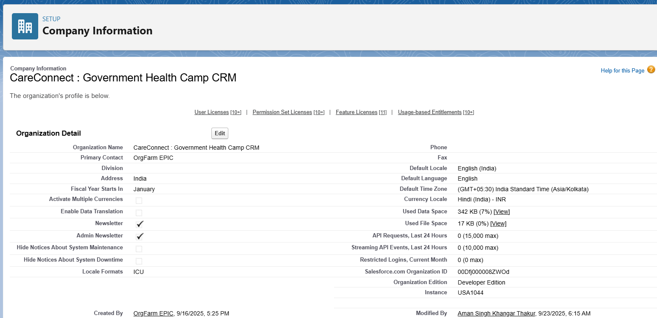Populated other basic details as per project requirements.

**4. Business Hours & Public Holidays**

* Defined **Business Hours** to match health camp operational timings (9 AM – 5 PM, Monday to Saturday).
* Added relevant **Holidays** to block inactive days during which no camps operate.

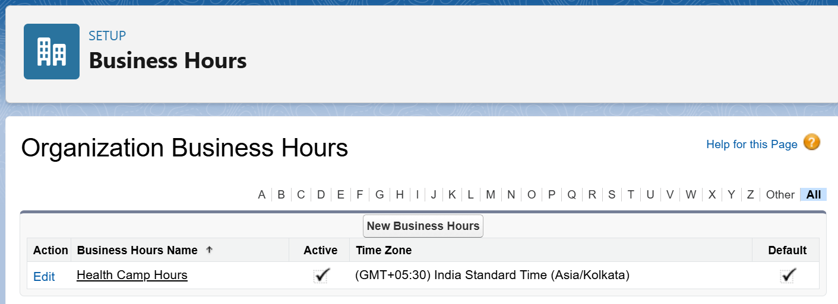

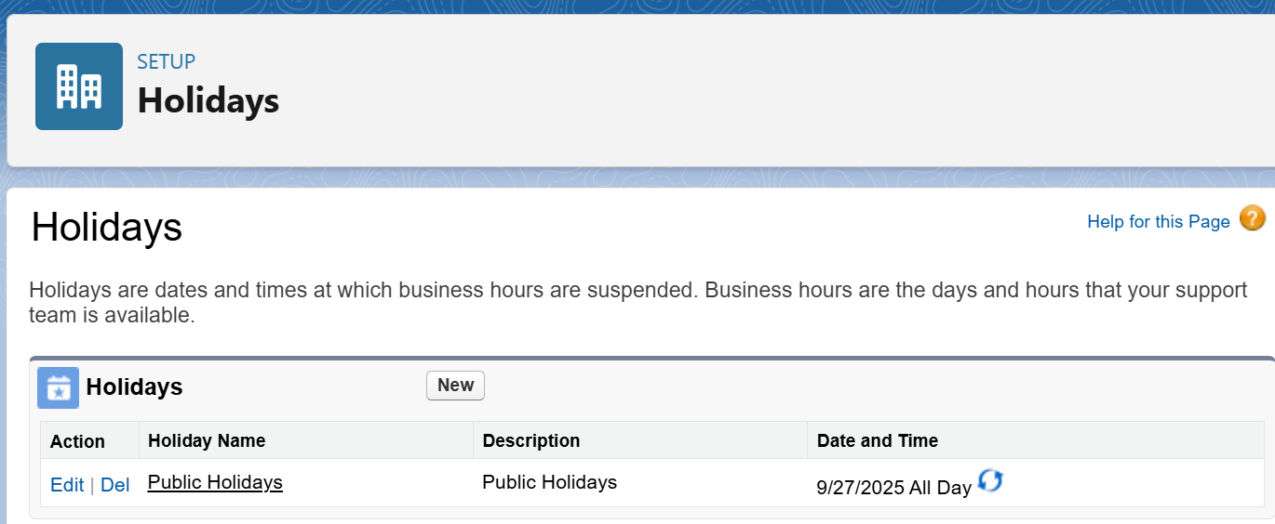

**5. User Setup & Licenses**

* Created users for roles:
  + Health Camp Coordinator
  + Medical Staff
  + Government Supervisor
* Assigned relevant **Salesforce Licenses** (Salesforce Platform License or Salesforce License).

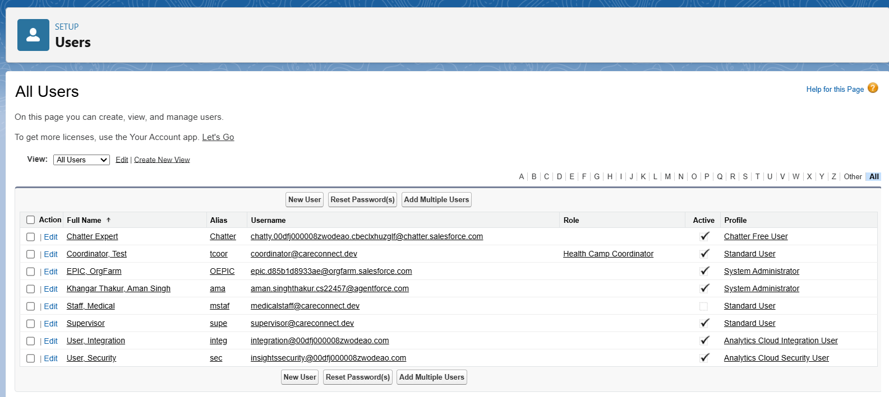

**6. Profile Management**

* Cloned **Standard User Profile** to create custom profiles tailored for:
  + **Health Camp Coordinator**: Full access to camp and appointment data.
  + **Medical Staff**: Limited access to assigned appointments and patient records.
  + **Government Supervisor**: Read-only access to all data for monitoring.

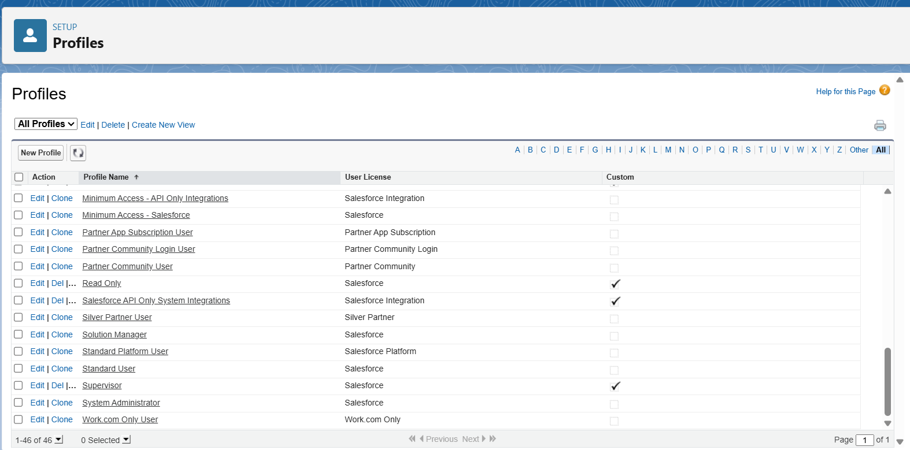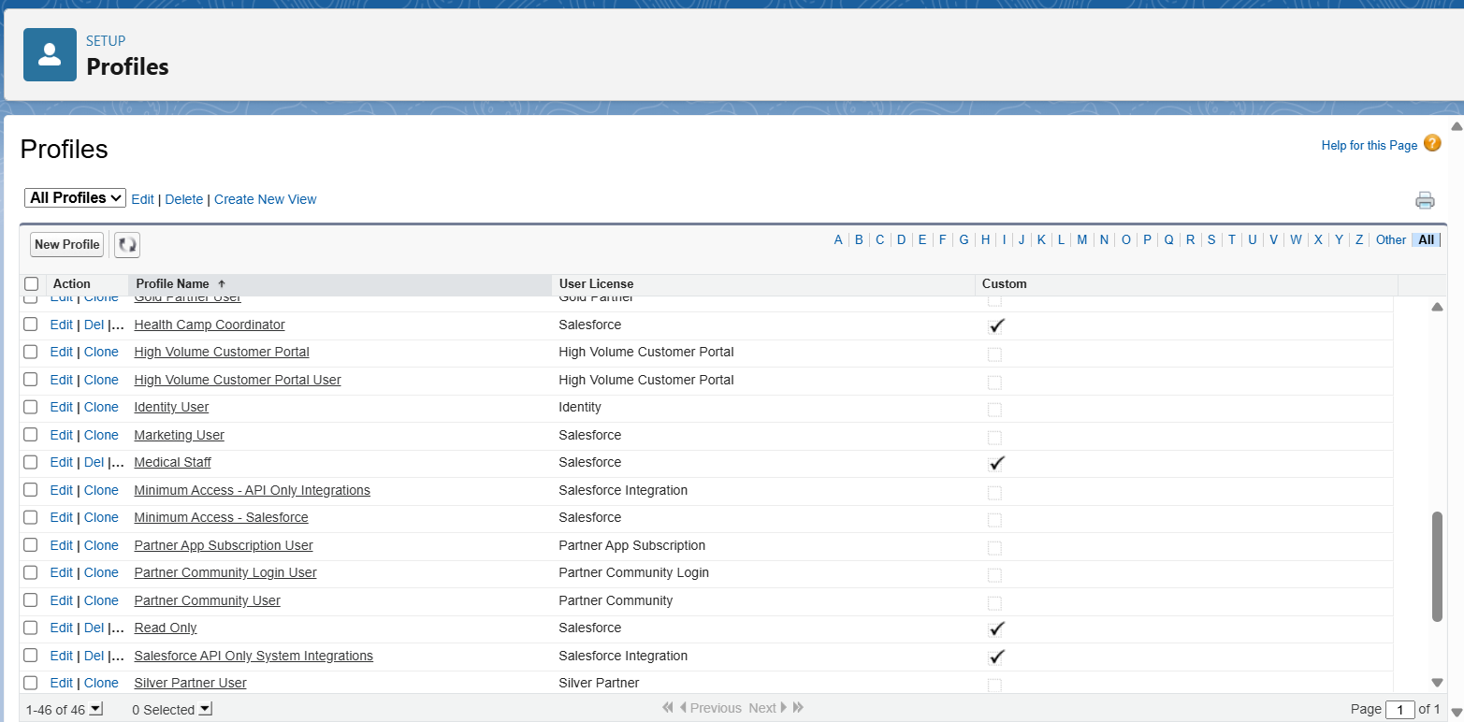

**7. Role Hierarchy**

* Created role hierarchy for data visibility:
  + **Government Supervisor** at the top.
  + **Health Camp Coordinator** midway.
  + **Medical Staff** at the bottom.
* A screenshot of a computer

  AI-generated content may be incorrect.This hierarchy ensures supervisors see all records, coordinators see their camps, and staff see their tasks.

**8. Permission Sets**

* Defined permission sets when additional privileges were required beyond profile permissions.
* 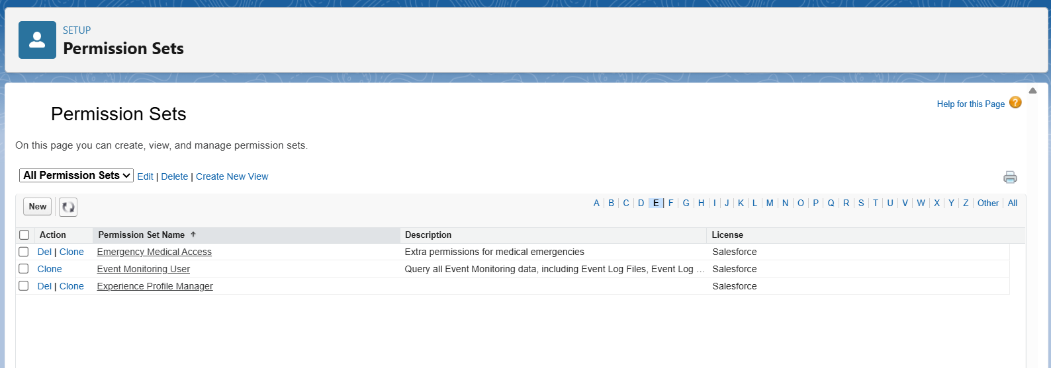Examples include access to reports, special admin tasks, or custom app features.

**9. Organization-Wide Defaults (OWD) and Sharing Rules**

* Set **OWD** for sensitive records (like Contacts/Patients) to **Private** for privacy.
* Created **Sharing Rules**:
  + Open access to Health Camp Coordinators for their own camps.
  + A screenshot of a computer

    AI-generated content may be incorrect.Restricted sharing for Medical Staff to only their records.

**10. Login Access & Security Policies**

* Configured **Login IP Ranges** for users as per organizational policy.
* A screenshot of a computer

  AI-generated content may be incorrect.Set **Session Timeout** and **Login Hours** as appropriate for security.

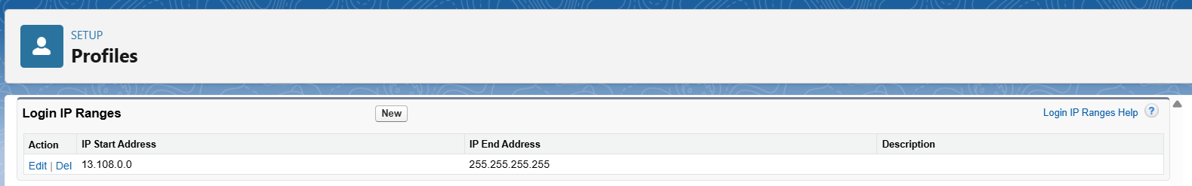

* **Phase 3: Data Modeling & Relationships**

**1. Introduction**

This document outlines Phase 3 of the CareConnect Government Health Camp CRM project. The focus is on creating an effective data model within Salesforce, using custom and standard objects, defining key fields, and establishing appropriate object relationships to reflect real-world government health camp operations.

**2. Objectives**

* Build custom objects representing Health Camps, Appointments, Medical Staff, and Equipment.
* Define data fields using the right data types for accurate capture.
* Implement relationships between objects for data integrity and ease of use.
* Customize Page and Compact Layouts for better UX.
* Visualize the data model using Salesforce Schema Builder.

**3. Custom Objects and Field Definitions**

**Health Camp (Health_Camp__c)**

* Camp Location (Text, Length 100)
* Camp Date (Date)
* Max Capacity (Number, 4 digits)
* Status (Picklist: Planned, Active, Completed, Cancelled)

**Appointment (Appointment__c)**

* Appointment Date/Time (DateTime)
* Status (Picklist: Scheduled, Completed, Cancelled, No Show)
* Patient (Lookup to Contact)
* Health Camp (Lookup to Health_Camp__c)

**Medical Staff (Medical_Staff__c)**

* Staff Name (Text)
* Role (Picklist: Doctor, Nurse, Support Staff)
* Assigned Health Camp (Lookup to Health_Camp__c)

**Equipment (Equipment__c)**

* Equipment Name (Text)
* Equipment Type (Picklist: Device, Supply)
* Assigned Health Camp (Lookup to Health_Camp__c)

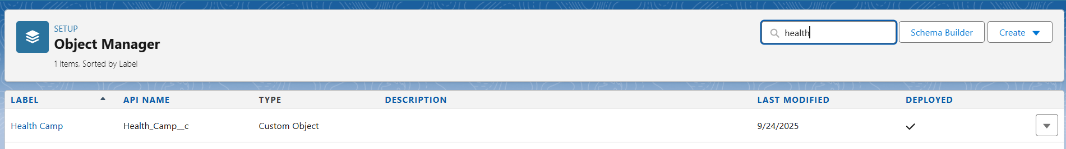

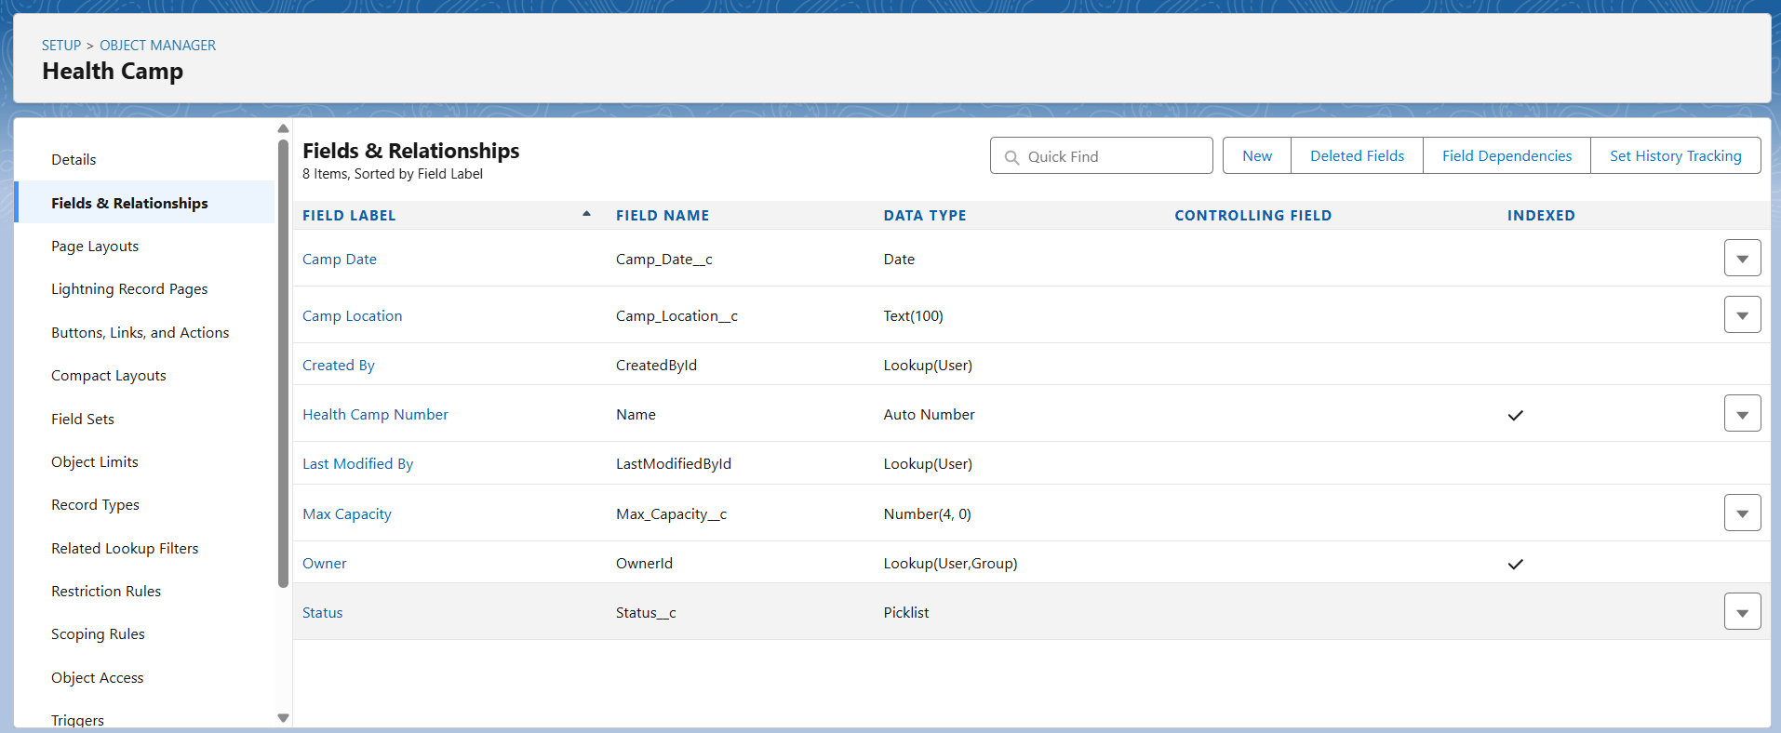

**4. Relationships**

**Lookup vs Master-Detail vs Hierarchical Relationships**

* **Lookup Relationship:**  
  A loose link between two objects. The child record can exist independently of the parent. Deleting the parent doesn't delete the child. Flexible but less tightly coupled.
* **Master-Detail Relationship:**  
  Strong binding where the child depends on the parent. Deleting the parent cascades delete to the child. Security and sharing settings are inherited.
* **Hierarchical Relationship:**  
  A special type of lookup relationship only available on the User object to represent user-to-user relationships (e.g., manager to team member).

**Usage in CareConnect:**

* Appointment to Patient (Contact) and Health Camp: Lookup Relationship
* A screenshot of a computer

  AI-generated content may be incorrect.Medical Staff and Equipment to Health Camp: Lookup Relationship (can be master-detail if you want cascade delete and strong binding)

**5. Junction Objects**

* Used to model **many-to-many relationships**. For example, when medical staff can be assigned to multiple health camps and a health camp has multiple staff members.
* Create a custom junction object with **two master-detail relationships** pointing to the two parent objects.

**6. External Objects**

* No external objects implemented in Phase 3.

**7. Page Layouts and Compact Layouts**

* Customize layouts to display key fields clearly.
* Add related lists for child records to parent pages (e.g., show appointments in Health Camp record)
* A screenshot of a computer

  AI-generated content may be incorrect.Define compact layouts for summary views in record highlights.

**8. Schema Builder Visualization**

* Use Salesforce Schema Builder to visually design and verify object fields and relationships.
* Adjust data model as needed after visual validation.

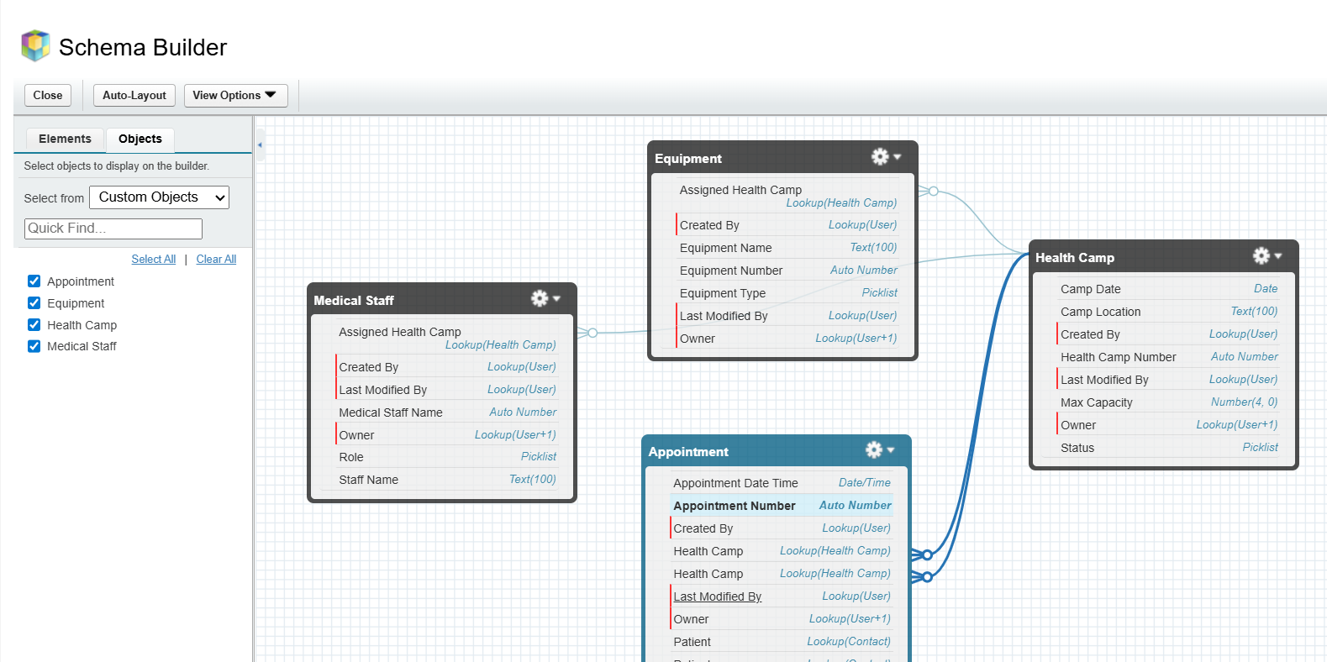

* **Phase 4: Process Automation**

**1. Introduction**

Phase 4 focuses on applying automation within the CareConnect CRM to improve efficiency and accuracy. This document outlines the tools and processes implemented to streamline health camp management workflows.

**2. Objectives**

* Automate validation rules to ensure quality of input data and prevent errors.
* Use workflow rules and process builder for sending timely email alerts, tasks, and field updates.
* Develop flows (screen, record-triggered, scheduled, auto-launched) for multi-step and automated processes.
* Configure approval processes where managerial confirmations are required.
* Send custom notifications to users and stakeholders for timely action.

**3. Validation Rules**

* Validated mandatory fields for appointment scheduling.
* Prevented invalid date/time entries for new appointments.
* Enforced appointment cancellation reasons.

**4. Workflow Rules**

* Triggered patient registration email notifications.
* Automated updating of camp capacity on new or cancelled appointments.
* A screenshot of a computer

  AI-generated content may be incorrect.Created reminder tasks for staff prior to camp start.

**5. Process Builder**

* Automated appointment status changes based on attendance.
* Synchronized related record updates such as patient records linked with appointments.
* Managed equipment availability updates on assignment.

**6. Flows**

* Screen Flow implemented for guided appointment booking for coordinators.
* Record-Triggered Flows used for real-time updates on appointment and camp records.
* Scheduled Flow created for automated health camp performance reports sent to supervisors.
* Auto-launched Flows used behind the scenes for field validation and data calculations.

**7. Approval Processes**

* Multi-level approvals configured for critical changes like camp cancellations and staff assignments.
* Email notifications set for supervisors on approval requests.
* A screenshot of a computer

  AI-generated content may be incorrect.Rejection comments and audit logging enabled.

**8. Email Alerts, Tasks & Notifications**

* Personalized email templates for patient confirmations and reminders.
* Task assignments automated for medical staff campaign preparations.
* Custom notifications sent to supervisors and coordinators for urgent camp updates.

* **Phase 5: Apex Programming**

In Phase 5, I implemented advanced Apex programming to extend automation capabilities that go beyond Flows and Process Builder. Below is the structured documentation of what I built, with supporting details.

**1. Classes & Objects**

* Implemented custom Apex classes to encapsulate business logic for appointments and health camps.
* Classes improve reusability and separation of concerns.
* Supporting point: This ensures logic can be reused by triggers, test classes, and future integrations.

**2. Apex Triggers (before/after insert/update/delete)**

* Developed triggers on the Appointment object to handle slot allocation for Health Camps.
* Used both after insert and after update to manage available slots dynamically.
* 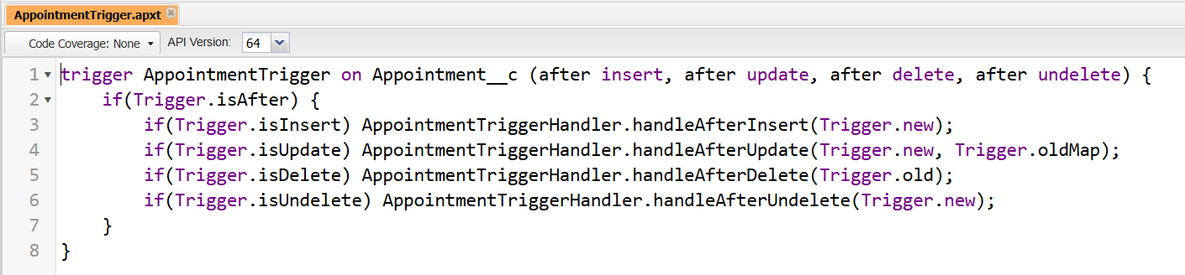Supporting point: Automates record updates without manual intervention.

**3. Trigger Design Pattern**

* Adopted the **trigger handler pattern** by separating logic into a dedicated handler class.
* Keeps trigger lightweight and only responsible for event routing.
* Supporting point: Enhances maintainability and prevents code duplication.

**4. SOQL & SOSL**

* Implemented SOQL queries to fetch Appointment and Health Camp records efficiently.
* Used selective queries with filters to comply with governor limits.
* Supporting point: Provides structured and controlled access to Salesforce data.
* No SOSL required for project use cases.

**5. Collections: List, Set, Map**

* Applied Lists to store multiple appointments.
* Used Sets for unique record IDs to prevent duplication.
* Implemented Maps for quick record lookups in trigger logic.
* 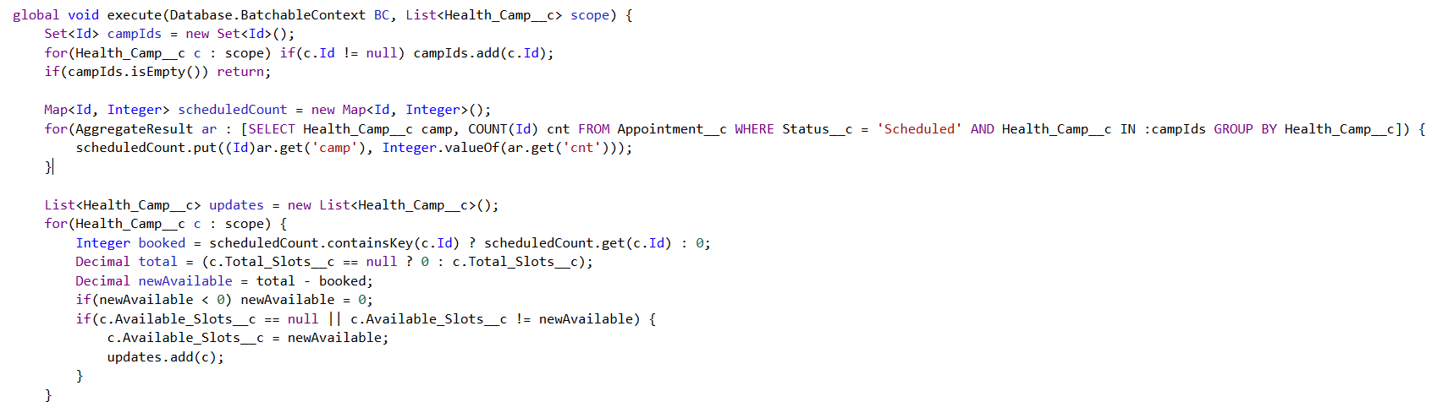Supporting point: Optimized performance and ensured data integrity.

**6. Control Statements**

* Incorporated if-else conditions for slot management (Scheduled, Cancelled, Deleted).
* Used for loops to iterate over record collections in bulk operations.
* 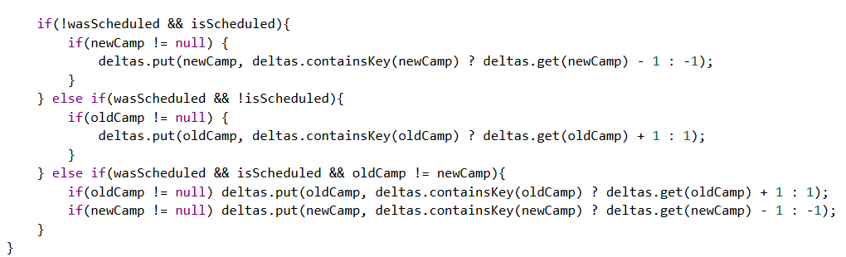Supporting point: Enabled decision-making and control flow in automation.

**7. Batch Apex**

* Created a Batch Apex class for reconciling Health Camp slots in bulk.
* Processes large volumes of data asynchronously without hitting governor limits.
* 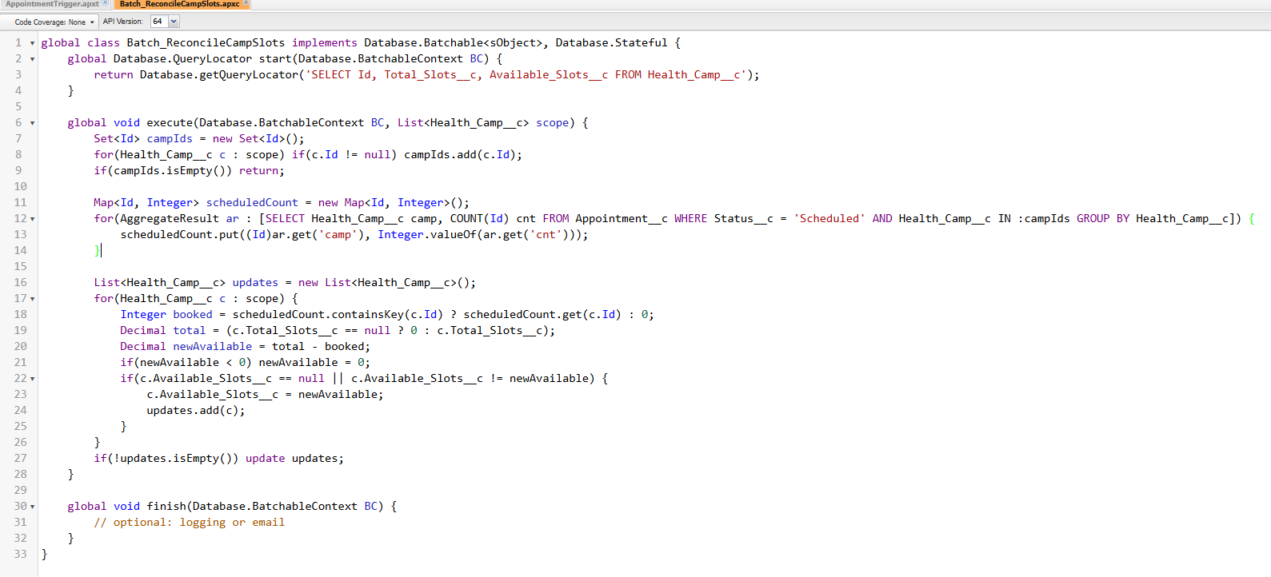Supporting point: Ensures data consistency during large-scale updates.

**8. Queueable Apex**

* Implemented Queueable Apex to send notifications to patients asynchronously.
* Allows job chaining for complex workflows.
* 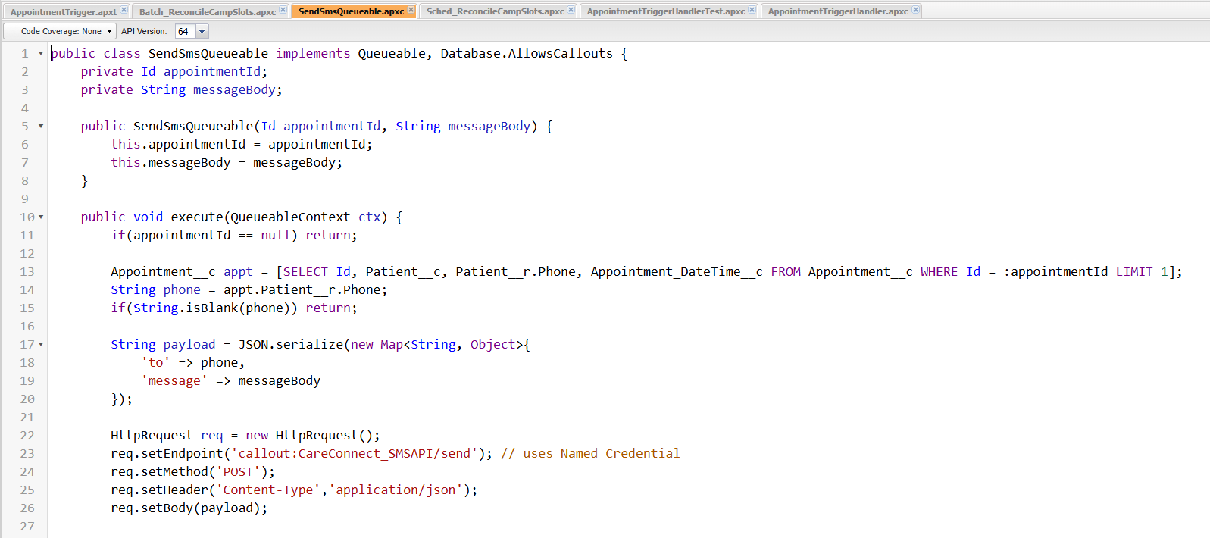Supporting point: Offers flexibility and reliability for background processes.

**9. Scheduled Apex**

* Built Scheduled Apex to run the Batch reconciliation process at defined intervals (e.g., nightly).
* Supporting point: Provides automated scheduling without manual runs.

**10. Future Methods**

* Used @future methods to handle callouts and lightweight async tasks.
* A computer screen shot of a computer screen

  AI-generated content may be incorrect.Supporting point: Decouples non-critical operations from the main transaction, improving performance.

**11. Exception Handling**

* Added try-catch blocks in Apex classes to handle unexpected errors.
* Logged failures for debugging and monitoring.
* 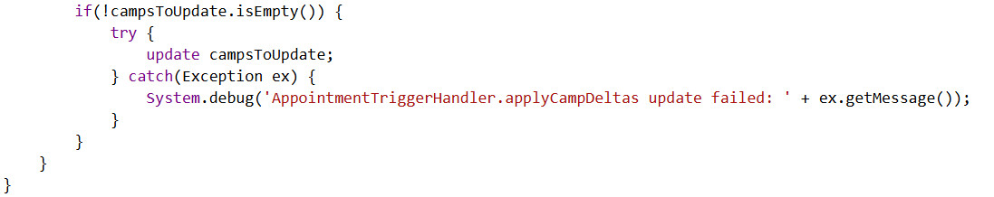Supporting point: Ensures smooth execution and prevents transaction rollbacks.

**12. Test Classes**

* Developed comprehensive test classes for all Apex triggers and classes.
* Achieved required code coverage (>75%) for deployment readiness.
* 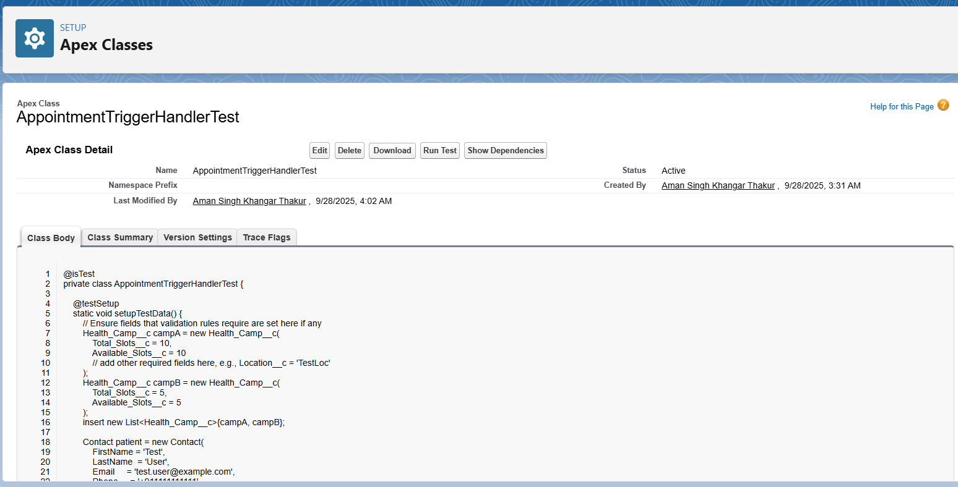Supporting point: Guarantees reliability of business logic and validates all possible scenarios.

**13. Asynchronous Processing**

* Implemented multiple async approaches: Batch Apex, Queueable Apex, Scheduled Apex, and Future methods.
* Supporting point: Handles high-volume operations efficiently and ensures Salesforce governor limits are respected.
* **Phase 6: UI Development**

1. **Lightning App Builder**

* Utilized Salesforce's point-and-click Lightning App Builder tool to create custom pages for both desktop and mobile experiences.
* Built consolidated landing pages for coordinators to access camp data, appointment lists, reports, and analytics.
* Customized Lightning apps by managing branding, navigation, options, and Lightning page assignments from within the app builder.

1. **Record Pages**

* Designed custom Lightning record pages for Health_Camp__c, Appointment__c, and Staff__c objects.
* Used component-based layouts to display related lists, calendars, and dynamic components improving user experience and speeding up data entry and visibility.

1. **Tabs**

* Configured key module tabs such as Camps, Appointments, Staff, Equipment, and Reports for intuitive navigation.
* Organized tabs to reflect user workflows and reduce search time for relevant records and pages.

1. **Home Page Layouts**

* Created custom home pages with important metrics, charts, notifications, and actionable items for supervisors and coordinators.
* Enhanced landing pages serve as quick start guides and status dashboards.

1. **Utility Bar**

* Implemented utility bars with frequently used tools such as recent records, global search, notifications, and custom quick actions.
* This improved access speed for support and field staff.

1. **Lightning Web Components (LWC)**

* Developed reusable LWCs to extend UI functionality in the app, including appointment quick actions, staff availability indicators, and camp status widgets.
* Components are optimized for performance on desktop and mobile.

1. **Apex with LWC**

* Integrated Apex controllers with LWCs to enable server-side logic like querying large data sets, executing validations, and bulk updates not achievable by UI alone.

1. **Events in LWC**

* Employed Lightning Web Components custom and standard events for inter-component communication.
* This ensured seamless updates between components such as updating appointment lists when a camp is modified.

1. **Wire Adapters**

* Used Wire Adapters to declaratively fetch Salesforce data into LWCs in reactive and efficient manner.
* This reduced manual API call overhead and improved UI responsiveness.

1. **Imperative Apex Calls**

* Implemented imperative Apex calls from LWCs to handle complex business logic and transactional operations invoked on specific user actions requiring confirmation before execution.